1. Open website: <https://notebooks.azure.com/glen-martin1/projects/china-stats-workshop>

Click “Projects” and return to the parent directory.

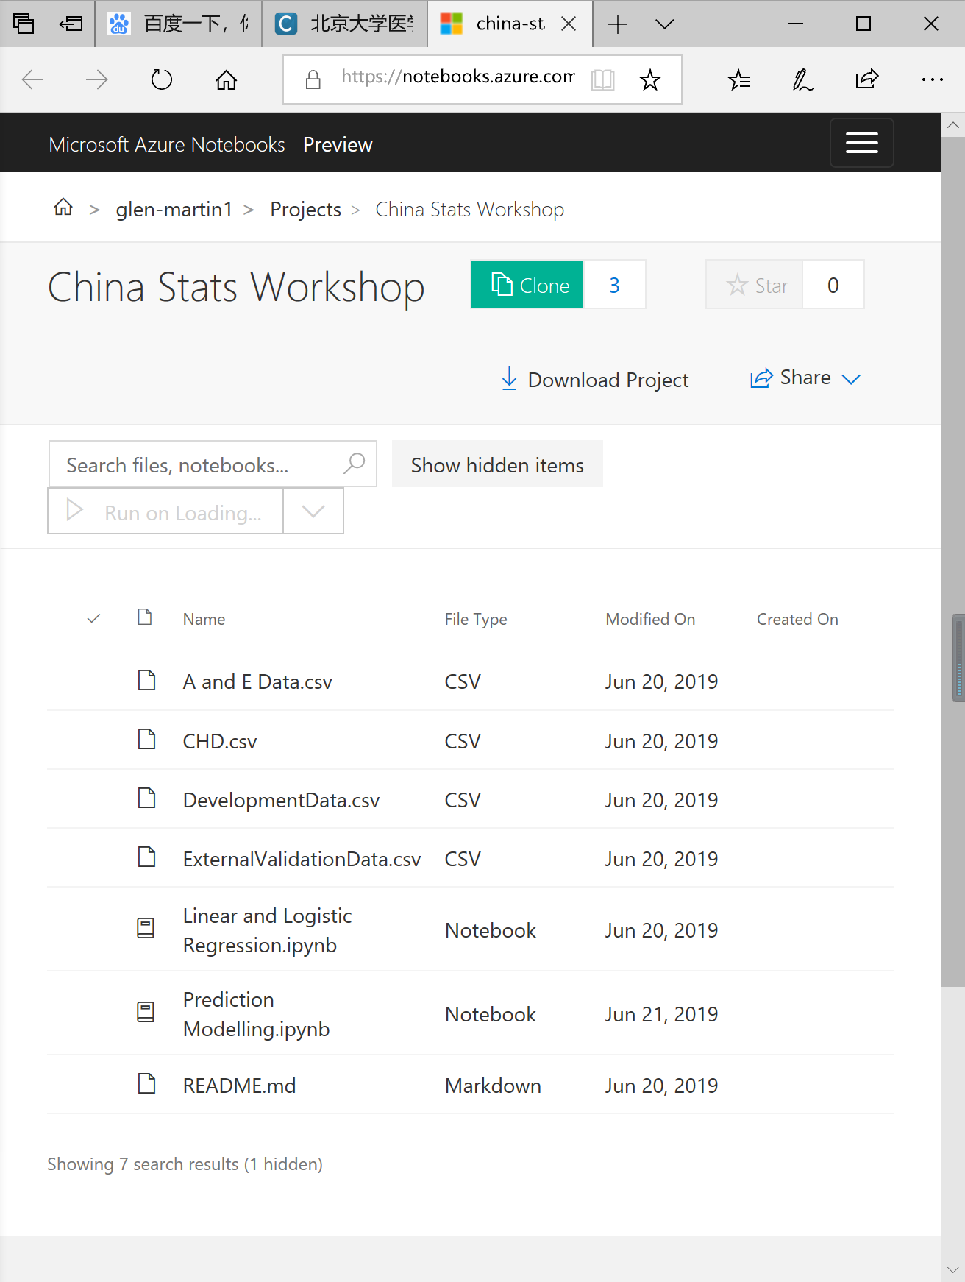

2. Select “China Stats Workshop” and click “Clone and run project” to clone the project into user’s own account.

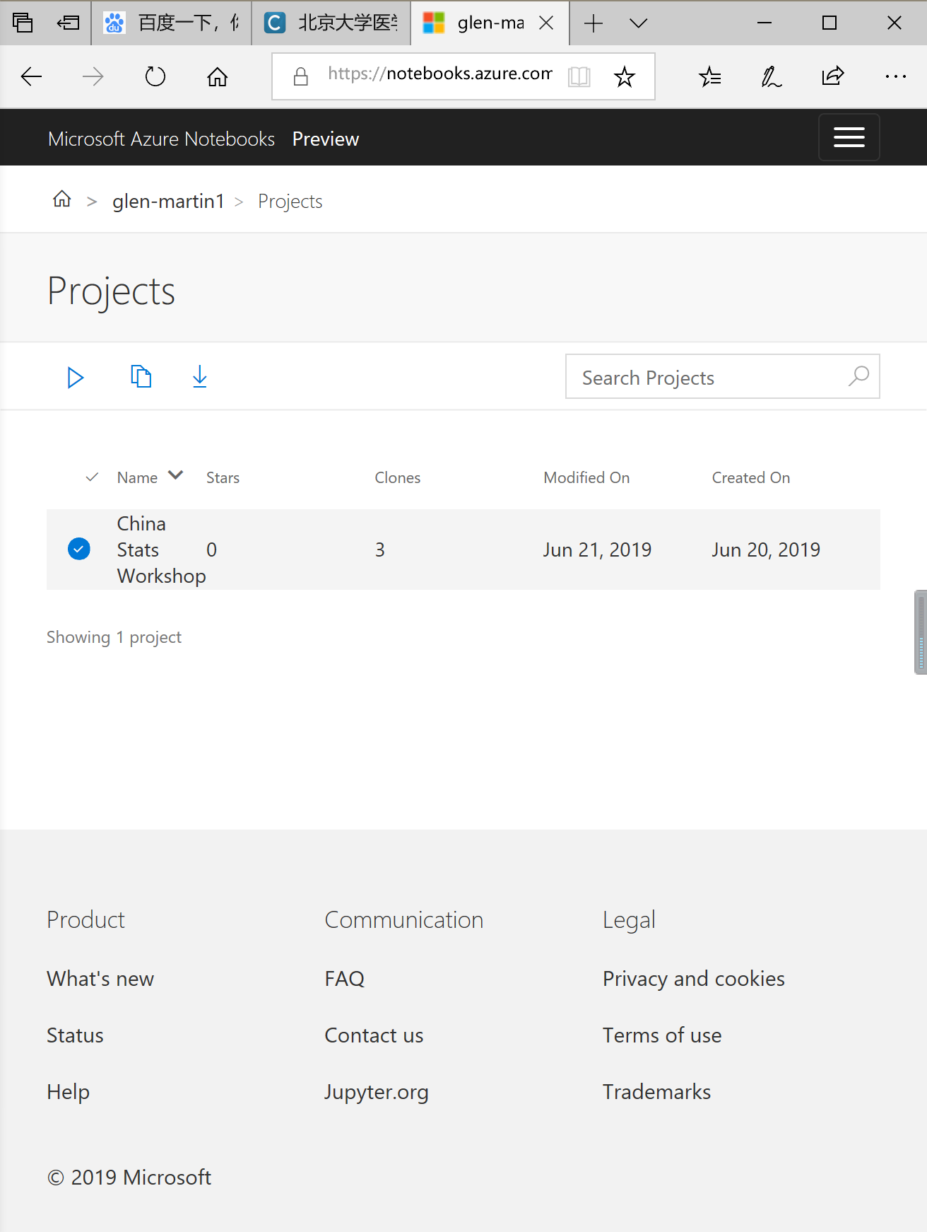

3. Sign in with user’s own Microsoft account.

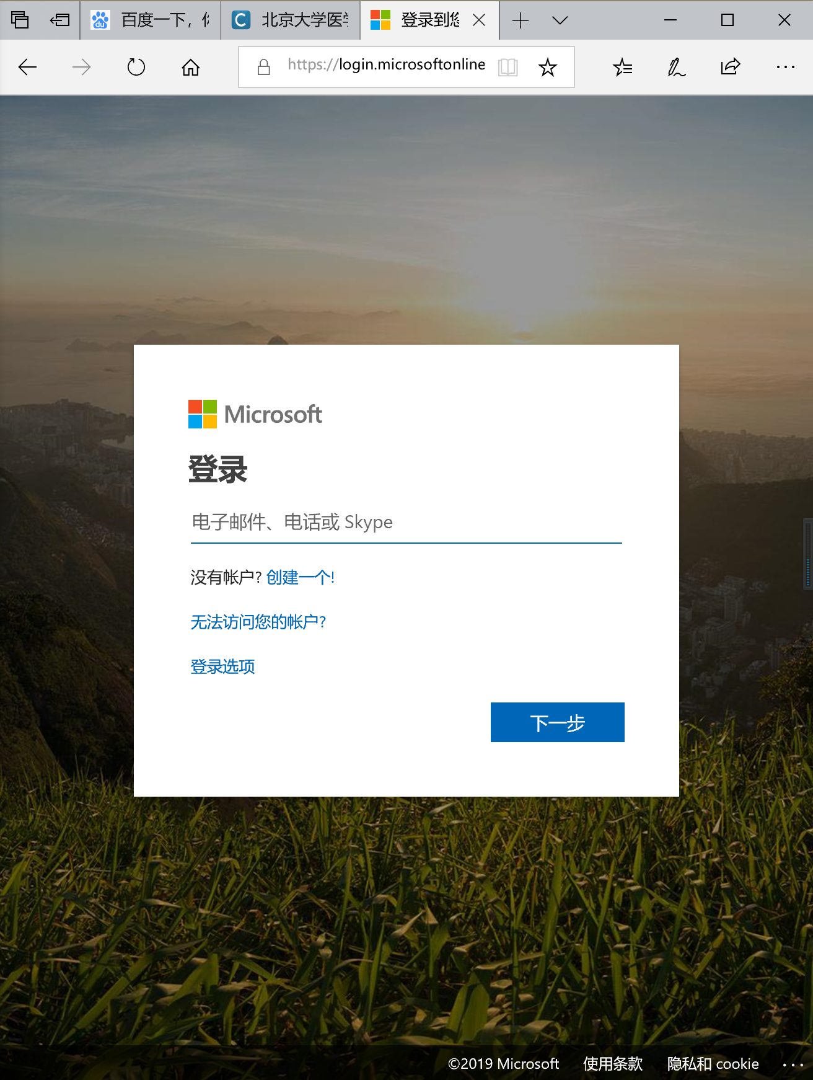

4. Rename the project in own account.

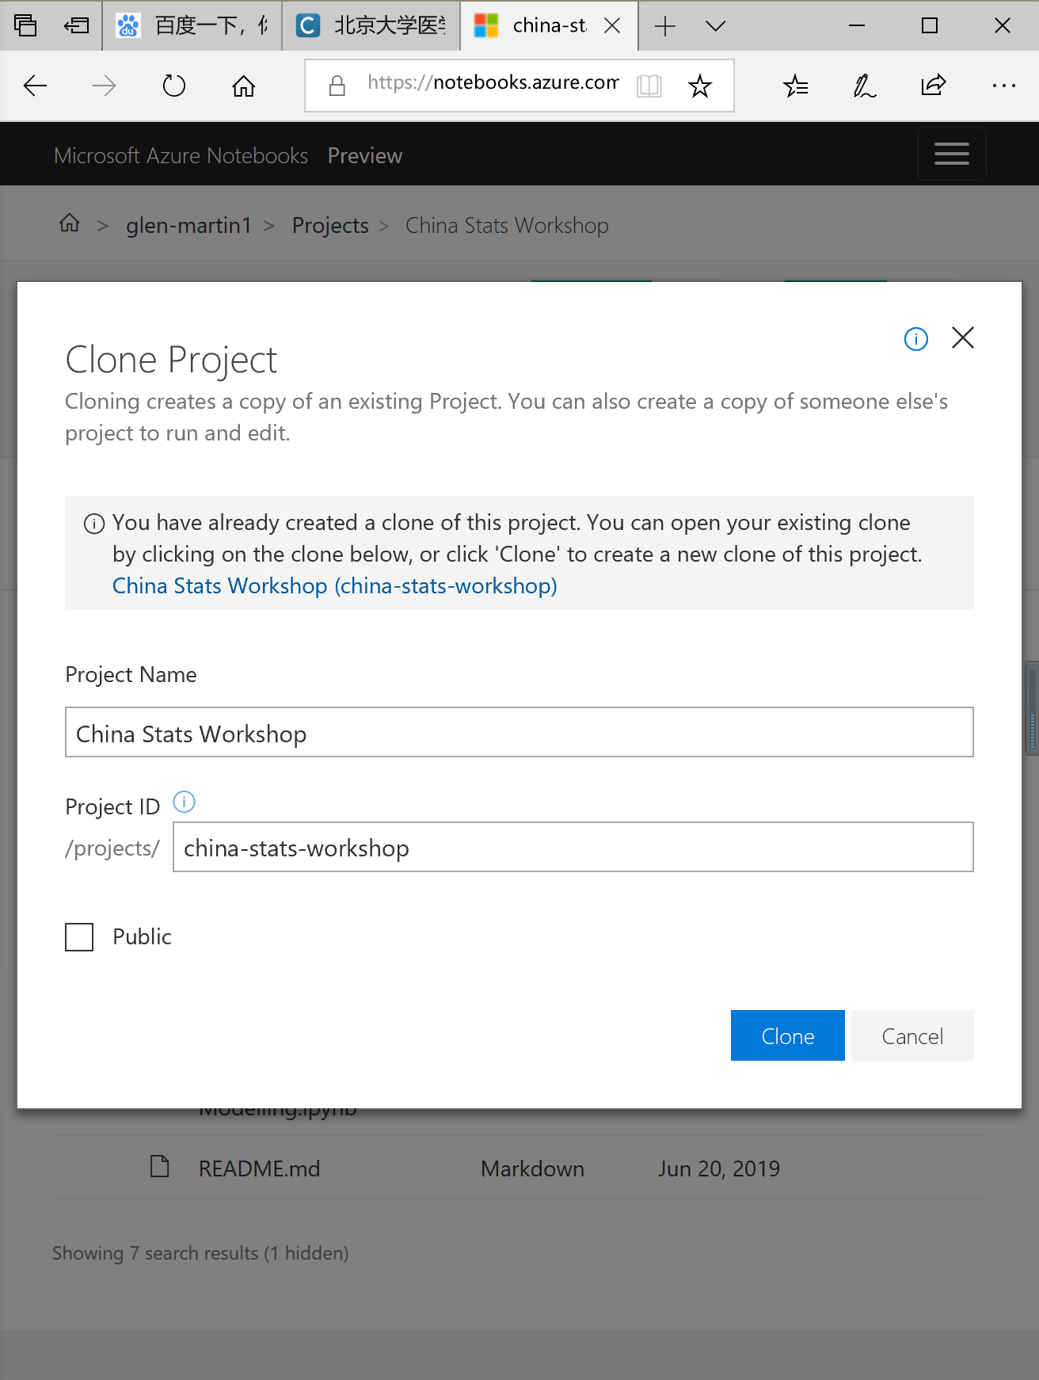

5. Clone the project successfully and re-enter the project in own account.

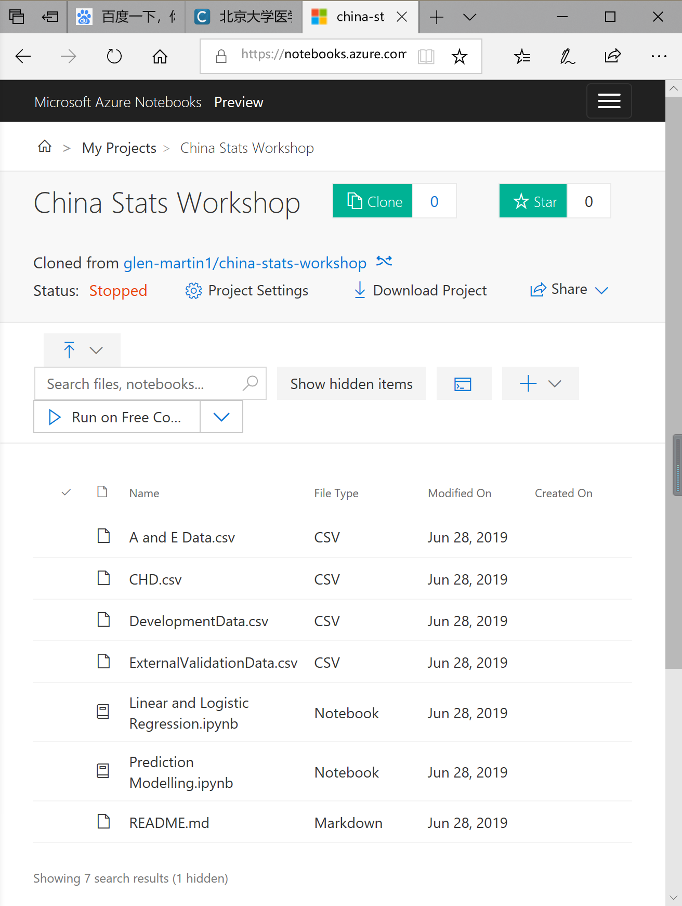

6. Click “Linear and Logistic Regression” and open this file in Jupyter Notebook.

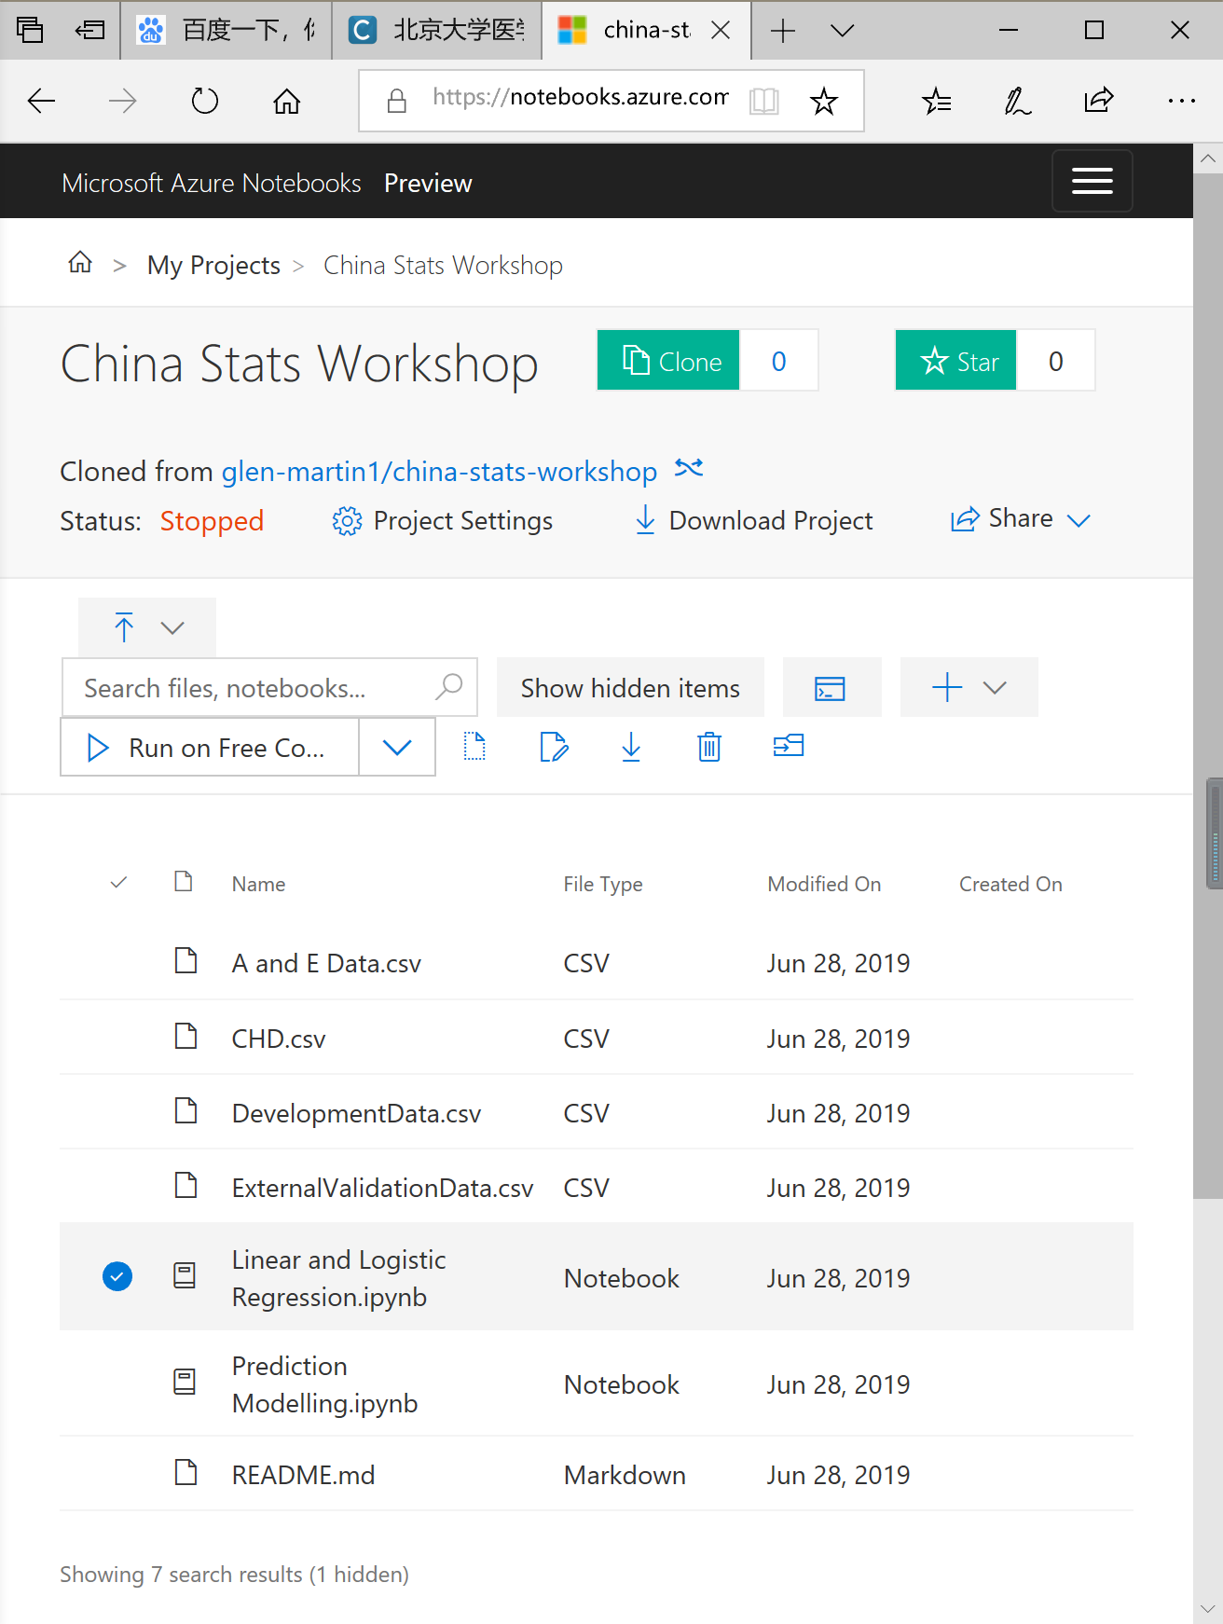

7. Run this file with Jupyter Notebook in Azure.

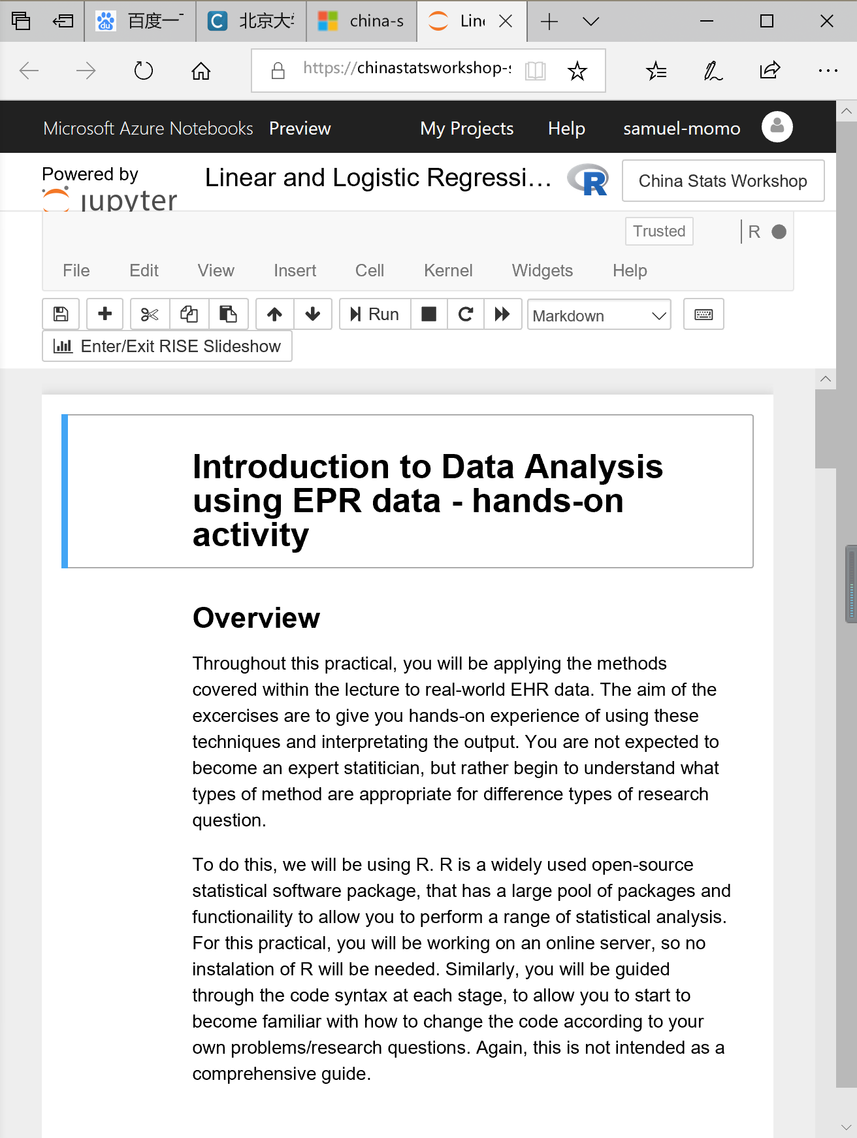

8. Select the code window and then click “Run” to do analysis with R.

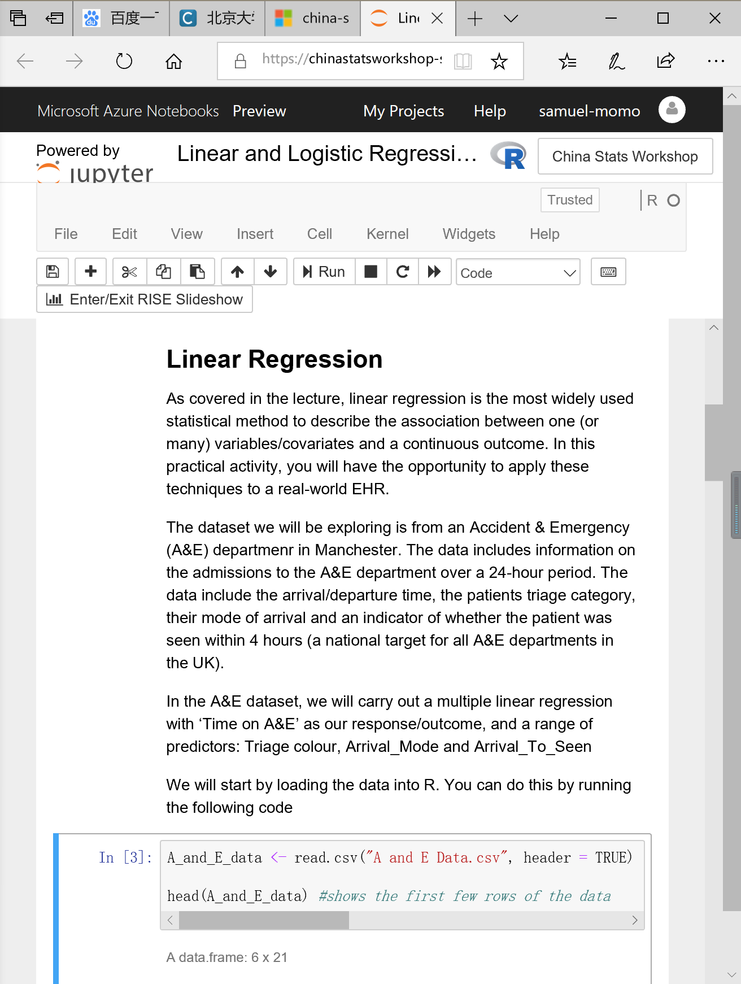

9. Doing analysis with R.

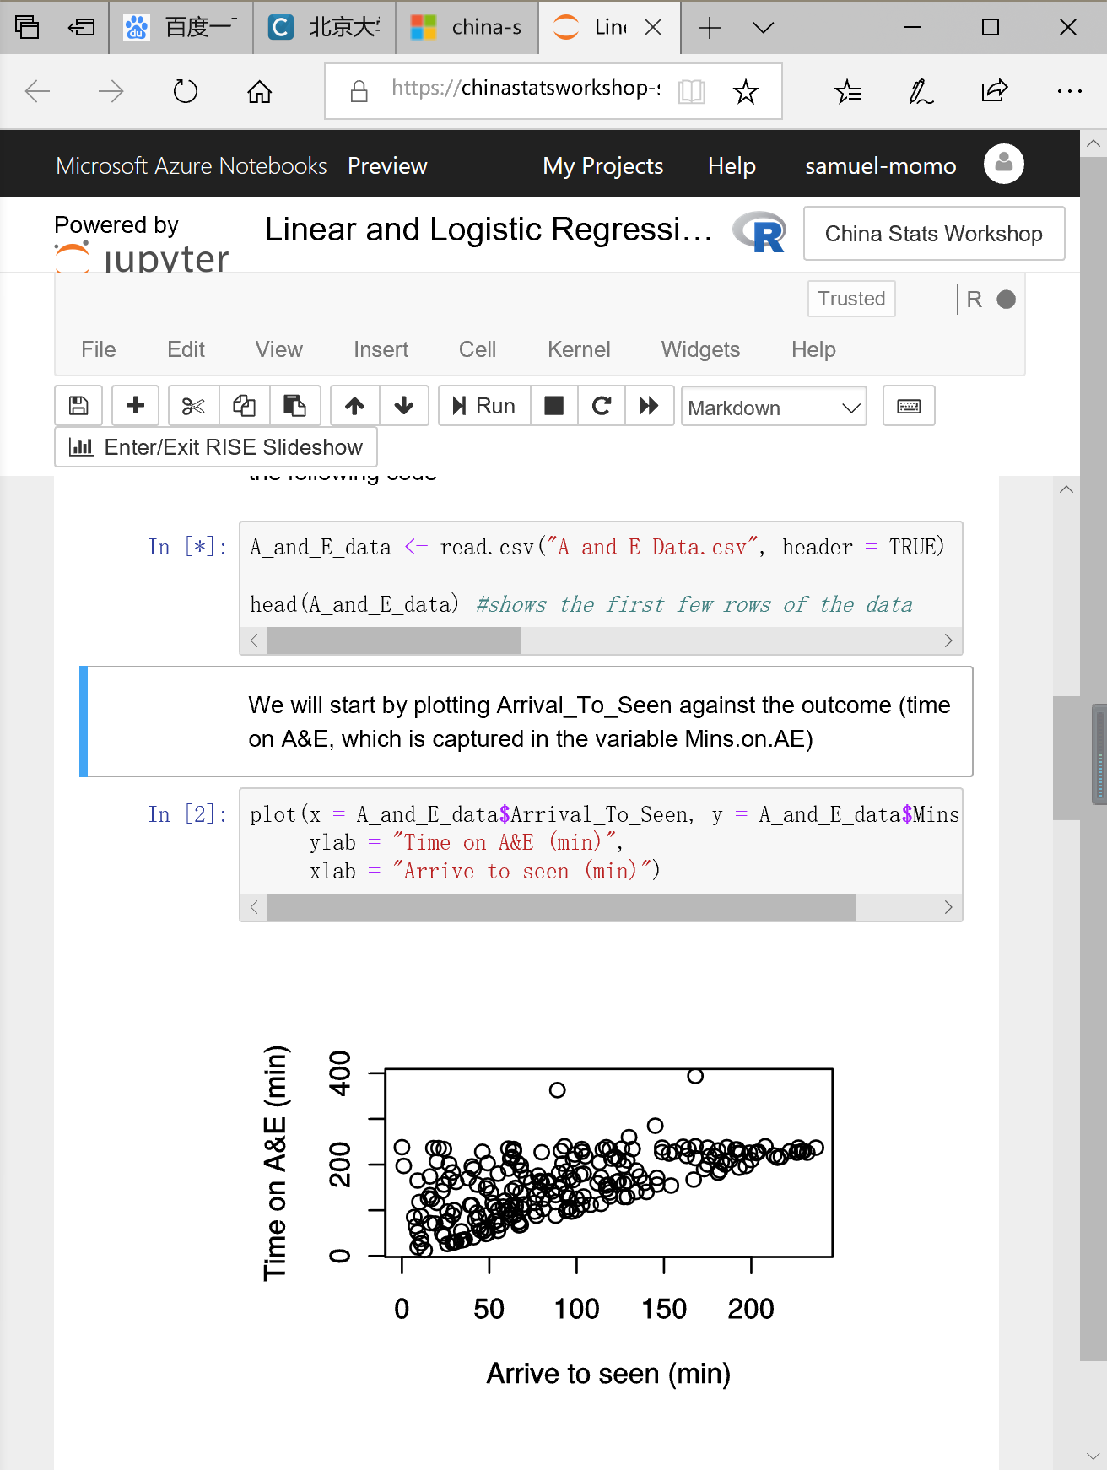

10. Analyze and display the analysis results.

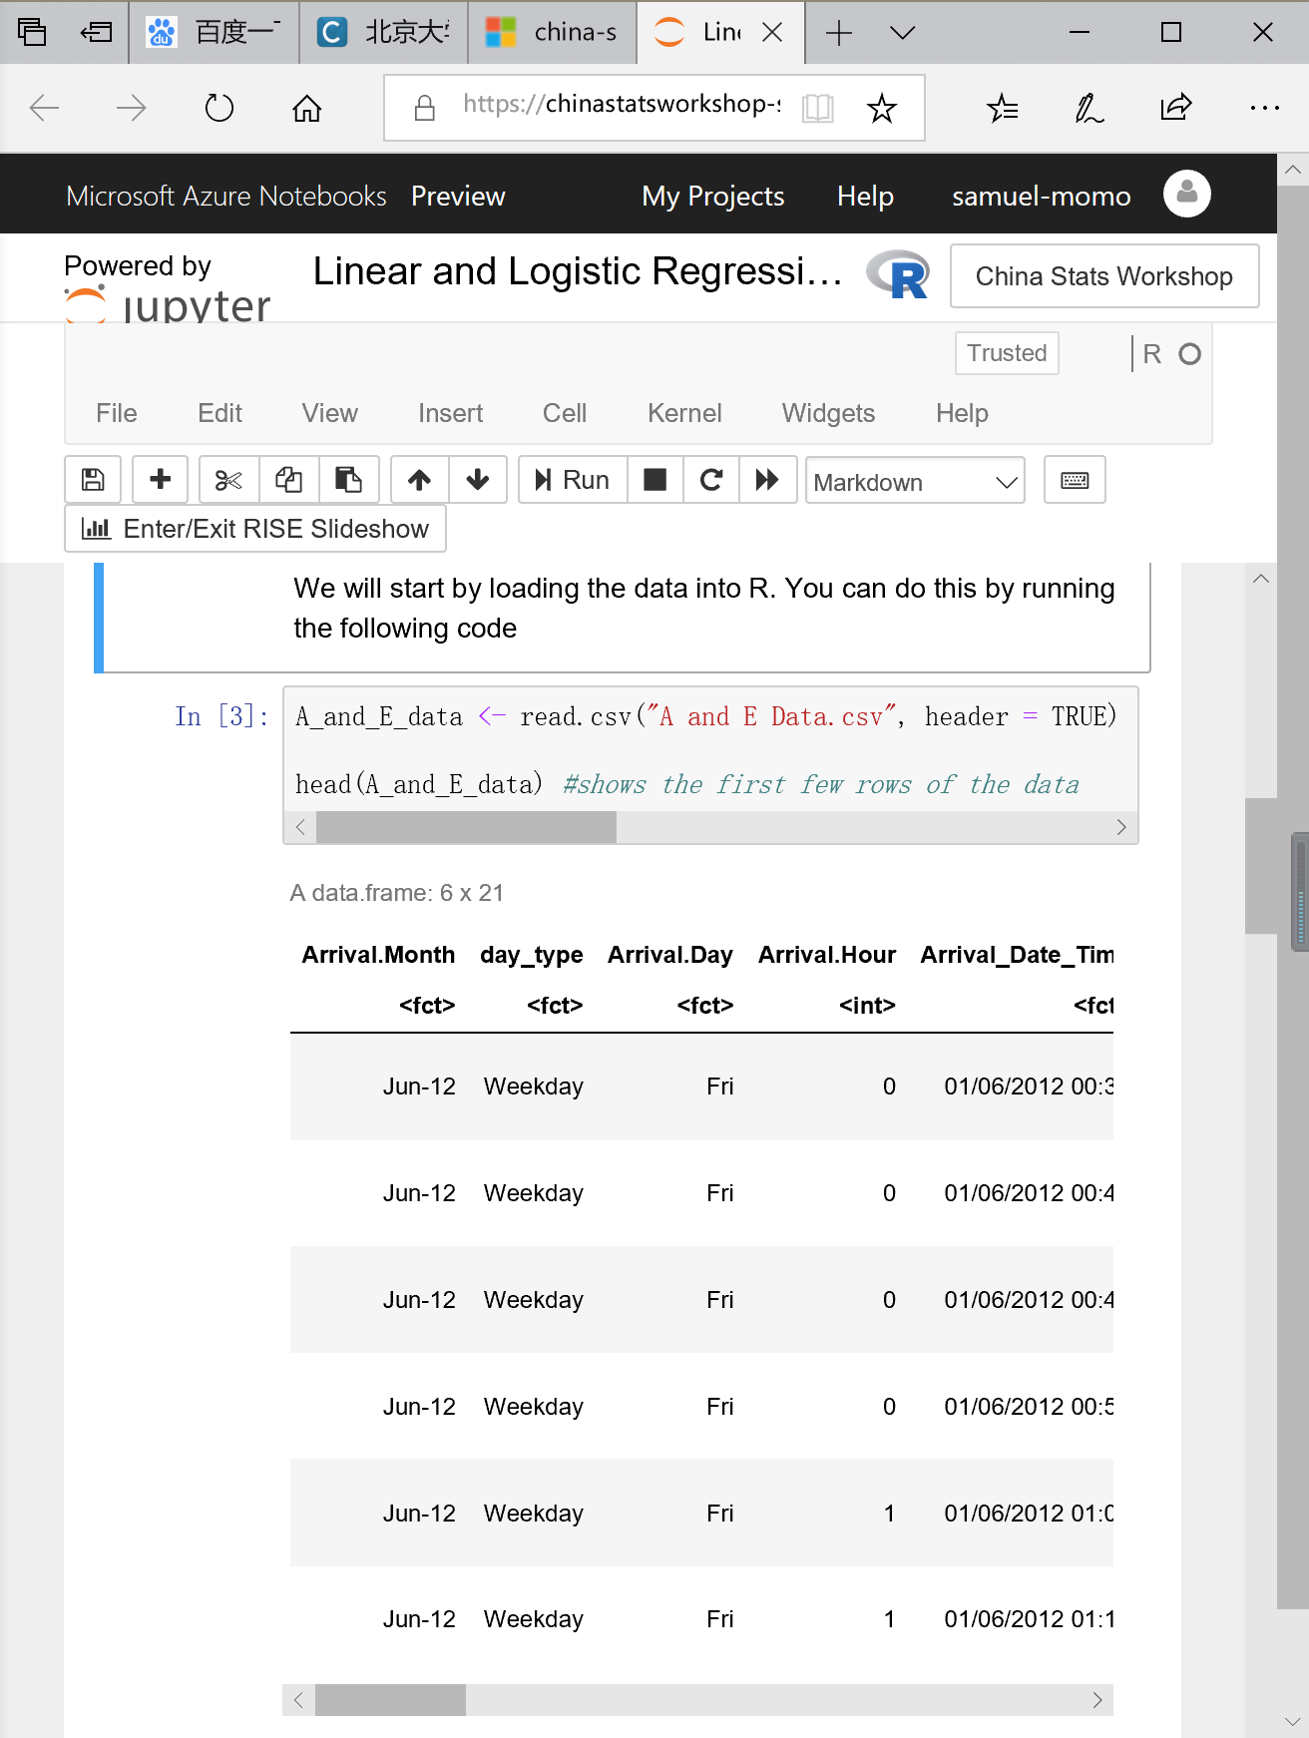

**Note**: Code files cannot be run in Jupyter Notebook without signing in with an account.

